

**Accessing the Research Computing Center Resources**

In order to use the Research Computing Center (RCC) resources you must first connect to the “**Midway2”** login nodes. Each of you will use your laptop/desktop to connect to this remote resource. The recommended choice for connecting to Midway2 is through the use of your ssh client, but one can also connect using the web based ThinLinc remote desktop client. Instructions for connecting to Midway2 using either the ssh client or the web version of the ThinLinc client are detailed below. (Please Note: if using a mac, any links found below may not work in adobe. Use Preview instead to view this pdf document with active links.)

Please note that in order to connect to Midway2 you MUST be enrolled with the University of Chicago two-factor authentication. Presumably all of you have already done so as Canvas requires you to authenticate with 2FA. If for some reason you have not yet enrolled you can do so by clicking the “Enroll in 2FA” link at the following site: <https://2fa.rcc.uchicago.edu/>

**Using the ssh client to connect to Midway2**

**1. SSH client setup**

This may or may not require some setup on your laptop, which will depend on whether you have a mac, windows or linux laptop. Instructions for Mac and Linux users

**Macintosh/Linux User Clients**

* Macintosh users will have a terminal client installed by default.

It is located in Applications -> Utilities -> Terminal. Verify you can locate the terminal client and add it to your dock. You can easily locate the terminal from the LaunchPad icon located in your Dock. Click the LaunchPad icon and search “terminal”. Drag the terminal icon into your dock and close LaunchPad.

* Other client terminals for Mac exist, but will require the user to install them. For example the [iterm2](https://www.iterm2.com/) terminal client is an alternative option.
* Mac does not come with X11 server preinstalled. In order to be able to display remote graphical processes from the terminal client, you will need to install X11 server and client libraries, which can be downloaded from the [XQuartz](https://www.xquartz.org/) project page. NOTE: Users are encouraged to install the older [2.7.8 version of XQuartz](https://www.xquartz.org/releases/XQuartz-2.7.8.html), which works with OpenGL applications.

**Windows User Clients**

* Windows users are recommended to either install [MobaXterm](http://mobaxterm.mobatek.net/) or [cmder](https://cmder.net/). It is strongly advised that you do not use Putty, and that if you were previously using it, you break the bad habit now. Windows Powershell is also an option, but only recommended for those who have previously set this up and are familiar with it. MobaXterm is a more full-featured terminal client that comes integrated with X11 server to allow rendering graphics through X windows on a remote server. MobaXterm also has an sftp tab built in to the client permitting ease of file transfer from remote to local machine.

**MobaXterm Install**

* Go to The MobaXterm site, and click either the **Download Tab** at the top or the

**Get MobaXterm button** on the middle of the page to redirect to the Download page.

* Choose the Free Home Edition of MobaXterm.
* Download the MobaXterm Home (Installer edition) zip file.
* Extract the contents of the zip file by right clicking it and choosing **extract**.
* Locate the MobaXterm_installer.msi file and double click it to install.
* MobaXterm will now be accessible from your Startup menu.

**2. Connecting via ssh client**

To connect to the remote compute cluster using your ssh client, each participant will need to do the following steps:

**Mac/Linux users**

* Open your terminal client. Search for ‘terminal’ in Finder.

To login with X11 enabled ssh to display graphics issue the following command:

ssh -Y <CNetID>@midway2.rcc.uchicago.edu

replacing <CNetID> with your Uchicago CNetID

When prompted for your password, type it in the terminal.

To login without X11 forwarding (no graphics can be displayed) issue the following

command:

ssh <CNetID>@midway2.rcc.uchicago.edu

**Windows users**

### Open your terminal client (MobaXterm) and click on the Sessions icon at the upper left hand corner of the client.Then perform the following numbered steps, illustrated in the figure below.

1) Click the SSH tab to expand the SSH login options.

2) In the **Remote host** field input: **midway2.rcc.uchicago.edu**

3) Select the **Specify username** button and input your username (this is your CNetID)

4) Proceed to login by clicking the **OK** button.

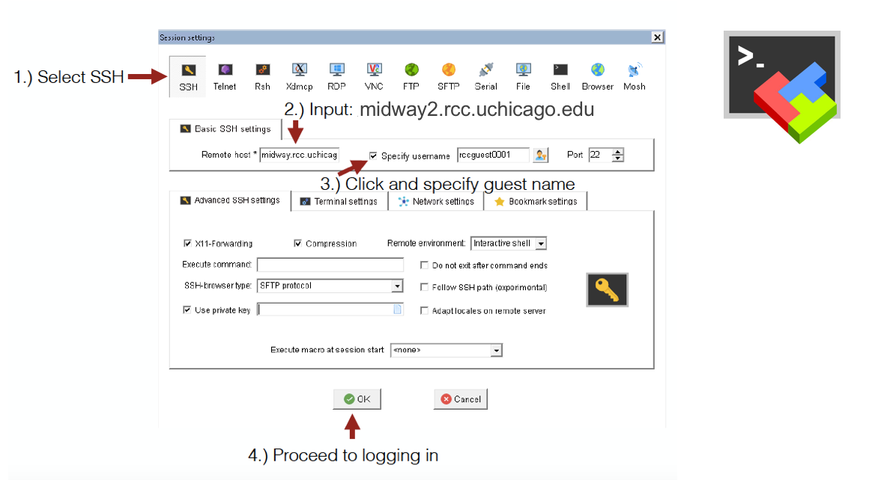

**Using the ThinLinc client to connect to Midway2**

We will be using the ThinLinc remote desktop server client to connect to the remote compute resources. Thinlinc has both a desktop and a web based version of the client. The desktop client requires installation on your laptop, whereas the web based version does not require any additional setup. We will use the web based version to connect to Midway2, though you may install the desktop client if desired or if there is some issue preventing the use of the web based client.

**Connecting to Midway2 with web based ThinLinc client**

Using the web based ThinLinc client makes connecting as easy as typing the following web address in your web browser address bar:

https:midway2.rcc.uchicago.edu

Provide your CNetID and password when prompted and then choose the two-factor authentication method to use to authenticate. It should be that simple. Should any problems arise with using the web based ThinLinc client, please ask first an instructor for assistance to ensure there is not some other unrelated issue before proceeding with alternative options for connecting.

Upon successful authentication, the remote Midway2 desktop will load in the browser window. It should look like the following image, where there are two drop down menu items (Applications and Places), and two icons on the desktop (Home folder and Trash bin).

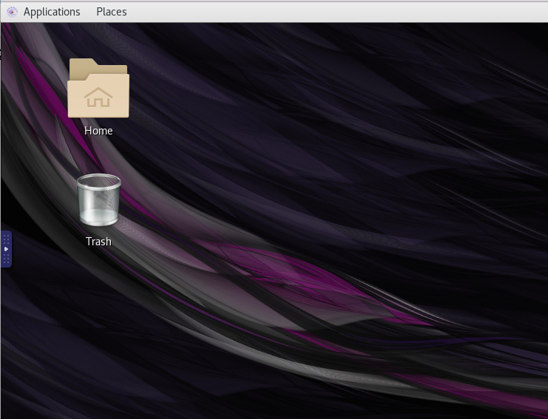

**Accessing the terminal from within the ThinLinc Client**

In order to access a terminal to use the command line and follow the rest of the instructions for the labs, you will need to locate the Terminal from within the Applications menu and select it to open a new terminal session.

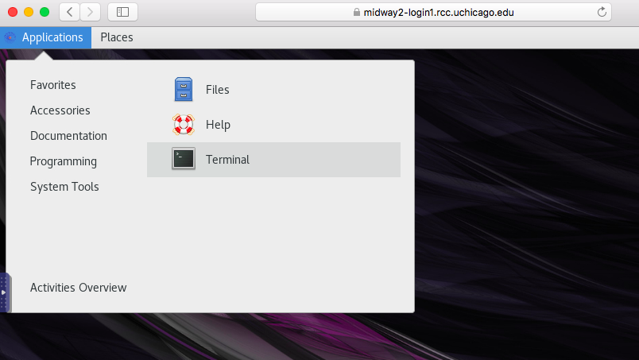

The terminal will display a prompt with your username AT the hostname (midway2-login1 or midway2-login2). This is the command line from which we will navigate the system and execute commands.

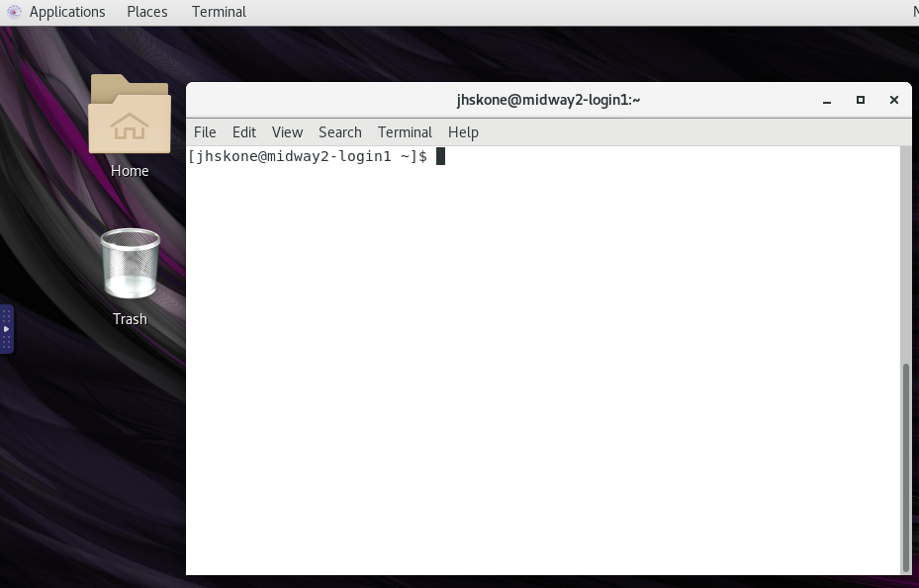

**Copying and pasting text within the ThinLinc Client**

One other item to bring to your attention with using the web based ThinLinc client is that you can not directly copy text from your local machine and paste it into the terminal or into a file through ThinLinc. You must first paste the text into the ThinLinc clipboard. Once the text resides on the clipboard, you can close the clipboard and proceed to paste the text within the terminal or a file in the ThinLinc client. To access the clipboard you must click the tab at the left of the screen to expand it and select the clipboard icon as shown in the image below.

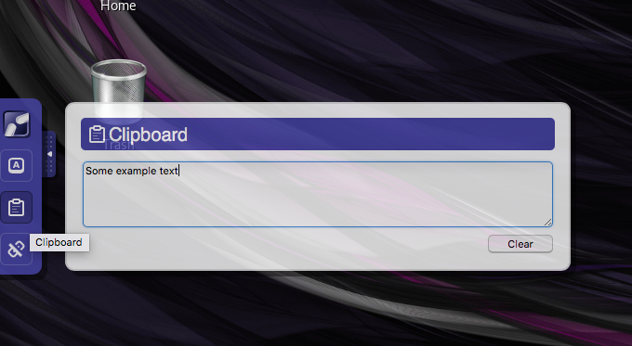

**Instructions for installing the Desktop ThinLinc client (if necessary)**

The instructions for downloading and installing on your laptop the ThinLinc Desktop client can be found on Cendio’s website: [ThinLinc Client Download](https://www.cendio.com/thinlinc/download) You do not need to use this version of the ThinLinc client as the web based client is adequate.

**Transferring files to and from the remote compute cluster**

You should not need to transfer anything to and from the remote compute cluster as we will work exclusively from the remote resource. But should a situation arise in which you need to move data to or from the remote Midway2 resource, then see the instructions for your particular laptop environment (Mac, Linux or Windows).

On **MAC** or **Linux** computers using the terminal run the following commands:

To copy a file from your local computer to your home directory on midway2:

scp your-file <CNetID>@midway2.rcc.uchicago.edu:~/

To copy a file from your home directory on midway2 to your local computer:

scp <CNetID>@midway2.rcc.uchicago.edu:~/file /local_directory_path

On **Windows**, **MAC**, or **Linux** you can use also a GUI-based client tool such as [FileZilla](https://filezilla-project.org/) or [Cyberduck](https://cyberduck.io/?l=en). Make sure when connecting, that you specify the location of the private ssh-key. MobaXterm has an sftp panel that allows you to drag and drop files between the remote server and your local machine.

### **The configuration for FileZilla (available for MAC, Linux, and Windows) is provided below and illustrated in the figure that follows.**

● Host: midway2.rcc.uchicago.edu

● Username: CNetID

● Port: 22

On **Windows,** for those who have installed the MobaXterm client, you can use the sftp tab to transfer data between midway2 and your laptop.

More information about data transfer on Midway2 can be found [here](https://rcc.uchicago.edu/docs/data-transfer/index.html). You can also mount the remote storage folder on your local desktop similar to what is done with DropBox or Google Drive. If you wish to use this option, follow the [SAMBA instructions here](https://rcc.uchicago.edu/docs/data-transfer/index.html#samba) for you specific operating system environment to mount your midway2 storage on your desktop. (Note: it can be buggy for windows users).